**Assignment - 12 A Job Ready Bootcamp in C++, DSA and IOT**

**Recursion in C Language**

**1. Write a recursive function to print first N natural numbers**

#include<stdio.h>

void firstNnaturalnum(int);

int main()

{

int x;

printf("Enter a number ");

scanf("%d",&x);

firstNnaturalnum(x);

return 0;

}

void firstNnaturalnum(int num)

{

if(num==0)

return;

firstNnaturalnum(num-1);

printf("%d ",num);

}

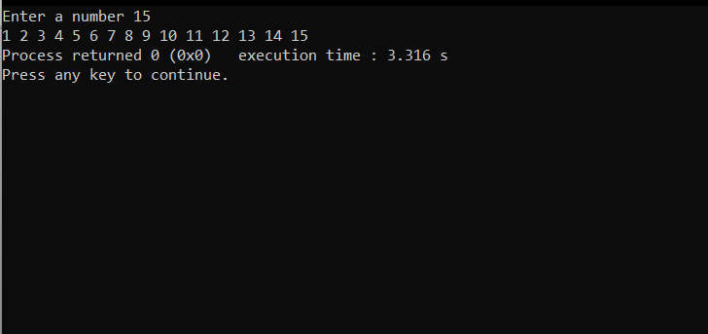

**2. Write a recursive function to print first N natural numbers in reverse order**

#include<stdio.h>

void firstNnaturalnum(int);

int main()

{

int x;

printf("Enter a number ");

scanf("%d",&x);

firstNnaturalnum(x);

return 0;

}

void firstNnaturalnum(int num)

{

if(num==0)

return;

printf("%d ",num);

firstNnaturalnum(num-1);

}

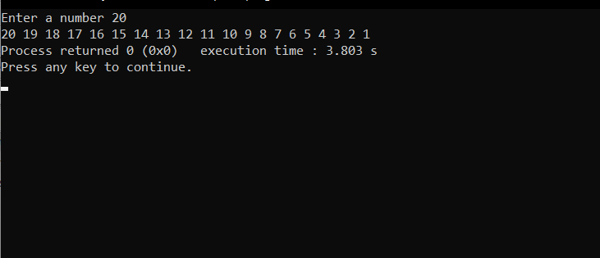

**3. Write a recursive function to print first N odd natural numbers**

#include<stdio.h>

void firstNnaturalnum(int);

int main()

{

int x;

printf("Enter a number ");

scanf("%d",&x);

firstNnaturalnum(x);

return 0;

}

void firstNnaturalnum(int num)

{

if(num==0)

return;

firstNnaturalnum(num-1);

printf("%d ",(num*2)-1);

}

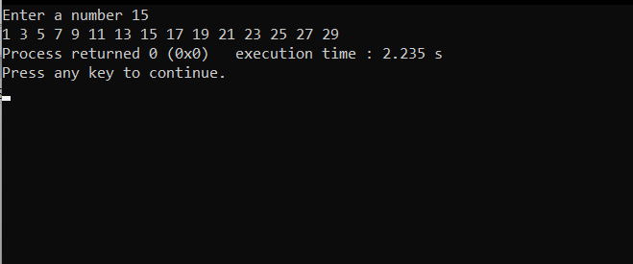

**4. Write a recursive function to print first N odd natural numbers in reverse order**

#include<stdio.h>

void firstNnaturalnum(int);

int main()

{

int x;

printf("Enter a number ");

scanf("%d",&x);

firstNnaturalnum(x);

return 0;

}

void firstNnaturalnum(int num)

{

if(num==0)

return;

printf("%d ",(num*2)-1);

firstNnaturalnum(num-1);

}

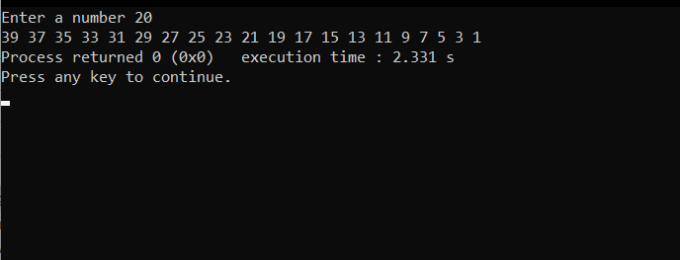

**5. Write a recursive function to print first N even natural numbers**

#include<stdio.h>

void firstNnaturalnum(int);

int main()

{

int x;

printf("Enter a number ");

scanf("%d",&x);

firstNnaturalnum(x);

return 0;

}

void firstNnaturalnum(int num)

{

if(num==0)

return;

firstNnaturalnum(num-1);

printf("%d ",(num*2));

}

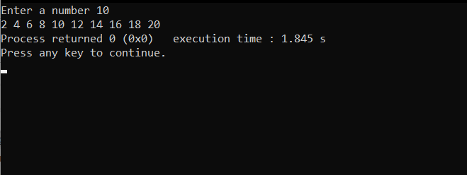

**6. Write a recursive function to print first N even natural numbers in reverse order**

#include<stdio.h>

void firstNnaturalnum(int);

int main()

{

int x;

printf("Enter a number ");

scanf("%d",&x);

firstNnaturalnum(x);

return 0;

}

void firstNnaturalnum(int num)

{

if(num==0)

return;

printf("%d ",(num*2));

firstNnaturalnum(num-1);

}

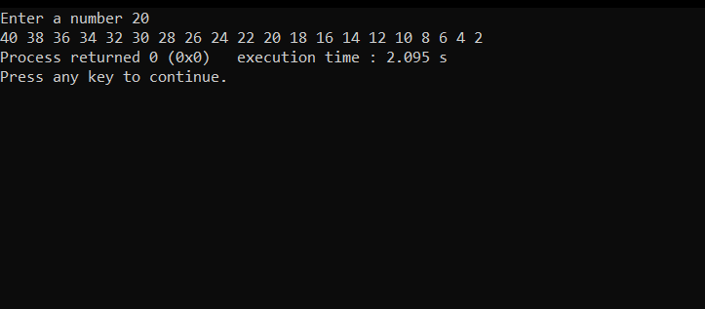

**7. Write a recursive function to print squares of first N natural numbers**

#include<stdio.h>

void firstNnaturalnum(int);

int main()

{

int x;

printf("Enter a number ");

scanf("%d",&x);

firstNnaturalnum(x);

return 0;

}

void firstNnaturalnum(int num)

{

if(num==0)

return;

firstNnaturalnum(num-1);

printf("%d ",(num*num));

}

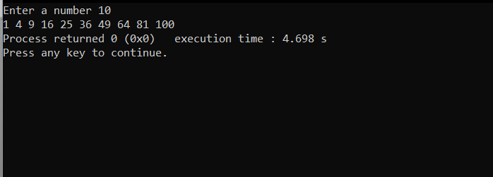

**8. Write a recursive function to print binary of a given decimal number**

#include<stdio.h>

void binary(int);

int main()

{

int x;

printf("Enter a number ");

scanf("%d",&x);

binary(x);

return 0;

}

void binary(int num)

{

if(num==0)

return;

binary(num>>1);

printf("%d",num&1);

}

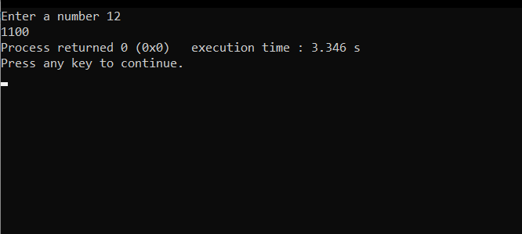

**9. Write a recursive function to print octal of a given decimal number**

#include<stdio.h>

void DectoOctal(int);

int main()

{

int x;

printf("Enter a number ");

scanf("%d",&x);

DectoOctal(x);

return 0;

}

void DectoOctal(int num)

{

if(num>0)

{

DectoOctal(num/8);

printf("%d",(num%8));

}

}

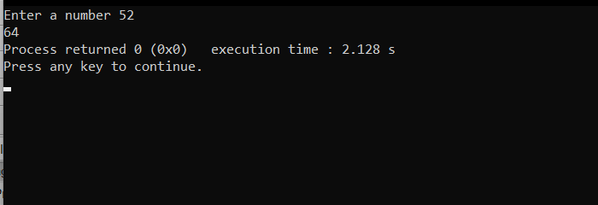

**10. Write a recursive function to print reverse of a given number**

#include<stdio.h>

void reverse(int);

int main()

{

int x;

printf("Enter a number ");

scanf("%d",&x);

reverse(x);

return 0;

}

void revrse(int num)

{

int rem=0;

if(num>0)

{

rem=(num%10);

printf("%d",rem);

reverse(num/10);

}

}

